Forms Experts Program

Domain Name: Nonrenewal Notice

Document Control Information

Document Information

|  |  |
| --- | --- |
| Document Name | Forms Experts Output_Nonrenewal Notice |
| Document Author | Anukriti Singh |
| Document Version | 1.0 |
| Date Released | 09/05/2013 |

Document Edit History

| Version | Date | Additions/Modifications | Prepared/Revised by |
| --- | --- | --- | --- |
| 1.0 | 09/05/2013 | Initial version | Anukriti Singh |
|  |  |  |  |
|  |  |  |  |
|  |  |  |  |

Table of Contents

1. Functional Domain 4

2. Business Justification 4

3. List of forms covered under the domain 4

*We had written stories for NJ which were later reverted to CL after CR408 changes. 4

4. Analysis of Business Requirements 5

4.1 Common Requirements 5

4.2 State-specific Requirements 5

4.3 Related Change Requests 6

5. Key Understanding of Design requirements 8

5.1 AH65XX for CL : Nonrenewal Notice 8

5.1.1 System/UI Impact 8

5.1.2 Impacted Stories 8

5.1.3 Signature Rules 8

5.1.4 Document Content and Applicable Triggers 9

5.2 AA65DE Nonrenewal Notice 10

5.2.1 System/UI Impact 10

5.2.2 Impacted Stories 11

5.2.3 Signature Rules(if any) 11

5.2.4 Document Content and Applicable Triggers 11

5.3 AH65XX for KY, ID, NY : Nonrenewal Notice 12

5.3.1 System/UI Impact 12

5.3.2 Impacted Stories 12

5.3.3 Signature Rules 12

5.3.4 Document Content and Applicable Triggers 13

5.4 AA65MD : Nonrenewal Notice 13

5.4.1 System/UI Impact 13

5.4.2 Impacted Stories 14

5.4.3 Signature Rules 14

5.4.4 Document Content and Applicable Triggers 14

5.5 AA65PA : Nonrenewal Notice 15

5.5.1 System/UI Impact 15

5.5.2 Impacted Stories 15

5.5.3 Signature Rules 15

5.5.4 Document Content and Applicable Triggers 15

6. Reference Documents 16

880-713CL 16

CR 0344 16

1. Functional Domain

Nonrenewal Notice

2. Business Justification

* Nonrenewal Notice informs the insured that their policy will not be renewed. It includes the reason for nonrenewal and the UW phone number to be contacted for assistance
* This notice is system generated when a policy has been keyed for nonrenewal with by a user or the automated renewal process.
* The nonrenewal is generated a specified number of days prior to the renewal date. This number of days will vary by state.
* There is also a nonrenewal notice days chart included at the end of this document for quick reference. The Product Specs should always be the primary source for this information.
* Dynamic text on the form may be keyed in the system by the user at the time when the nonrenewal is keyed.
* If the nonrenewal is system initiated, the dynamic text will always be conditional based on the reason for nonrenewal.
* This form is common to Auto and Property products.
* Nonrenewal Notice is usually accompanied by state specific notice informing the insured about necessary state regulations.
* The possible nonrenewal reasons that will trigger this notice vary by state and can be found from the Product Lookup of the state.

3. List of forms covered under the domain

| Form No. | State initials | Form Name |
| --- | --- | --- |
| AH65XX | CL | Nonrenewal Notice |
| AH65XX | NY | Nonrenewal Notice |
| AH65XX | ID | Nonrenewal Notice |
| AH65XX | KY | Nonrenewal Notice |
| AA65DE | DE | Nonrenewal Notice |
| AA65PA | PA | NOTICE OF CANCELLATION OR REFUSAL TO RENEW |
| AA65MD | MD | Nonrenewal Notice |

*We had written stories for NJ which were later reverted to CL after CR408 changes.

4. Analysis of Business Requirements

## Common Requirements

| Form No. | Form Name | Form Description and its Business Use |
| --- | --- | --- |
| AH65XX | Cancellation Notice | * System or user will flag policy for nonrenewal prior to the generation of the renewal offer. * X # of days prior to renewal, the nonrenewal notice will be produced if the policy has been flagged for nonrenewalThis notice is generated when a policy is cancelled midterm. * If the notice generation date falls on a weekend or holiday, the nonrenewal will produce earlier, on the business day prior. * Prints via central print * Copy of notice should appear in the e-folder and Fastlane |

## State-specific Requirements

| Form No. | State initials | Form Name | Form Description / State Specific Delta |
| --- | --- | --- | --- |
| AH65XX | NY | Nonrenewal Notice | Delta to CL :   1. State specific notices added for NY. 2. Up to 10 lines of reason text may be printed for the dynamic non-renewal reasons. |
| AH65XX | ID | Nonrenewal Notice | Delta to CL:   1. State specific language in state specific notice. |
| AH65XX | KY | Nonrenewal Notice | Delta to CL:   1. The Nonrenewal reason must be free text typed by the user and must be a statement reasonably calculated to inform the insured of the reason for Nonrenewal. 2. System generates 77 days prior to expiration date of policy. 3. State Specific notices. |
| AA65DE | DE | Nonrenewal Notice | New Form:   1. State Specific Notice will print depending on nonrenewal reason. 2. State Notices Section- Back page section is a variable and will only display if the nonrenewal is a result of driving activity. |
| AA65PA | PA | NOTICE OF CANCELLATION OR REFUSAL TO RENEW | New Form:   1. Form name and number. 2. State Specific Notice will print depending on cancellation reason. 3. State Notices Section- Back page . |
| AA65MD | MD | Nonrenewal Notice | New Form:   1. State Specific Notice will print depending on nonrenewal reason. 2. State Notices Section- Back page section is a variable and will only display if the nonrenewal is a result of driving activity |

## Related Change Requests

| CR No. | CR Name | States Impacted | CR Description and its Business Use |
| --- | --- | --- | --- |
| CR 0383 | Non Renewal and Cancellation Notice | MD, CO, DE | **Problem Statement:**  The following specific information is to be printed in the Nonrenewal and Cancellation Notices which is not captured by PAS system:   * 1. Incident/accident that caused a non-renewal or cancellation   2. Offer to Exclude Drivers based on the result of accident(s), violation history or claims experience.   3. Notice of Consumer Report Information based on result of information contained in an MVR or CLUE report   4. Underwriting Guidelines – Free form text   **Change:**  Driver Activity section should be displayed on UI when cancellation is a result of driver activity.  ‘Offer to Exclude Named Driver(s)’ check box is checked only when cancellation is a result of driver activity  If the exclusion offer is offered, the ‘Recalculated Premium’ is displayed .   * There were a number of UI and other changes due to this CR |
| CR0408 | Common Forms AH61 and AH65 | AZ, CT, CO, DE, ID, IN, KS, MD, NJ, NV, NY, OH, OK, OR, PA, SD, UT, VA, WY | **Problem Statement:**   * To add variable text to AH61XX , AH65XX forms per legal requirements * Changes to be made to CL and also the states where ever delta is to be called out   **Change:**   * AH61 will now read as “Your policy will be cancelled…” and AH65 will read as “Your policy will be nonrenewed * 130-163CL will be made part of 880-713 as it details about the content of a section of the form |

5. Key Understanding of Design requirements

## AH65XX for CL : Nonrenewal Notice

### System/UI Impact

| Page | Yes/No | Page Section |
| --- | --- | --- |
| Forms | | No | N/A | |
| *Note: Indicate section where form will display, if applies. See Policy, Driver, and Vehicle Endorsement tabs in the Product Lookup)* | |
| Documents | | No | N/A | |
| *Note: Indicate section/s where the form will display, defaults for “yes” and “no” button, if applies* | |
| GODD | | No | N/A | |
| *Note: Indicate whether document will appear on the page from Quote and/or Policy consolidated view, also the order of where on the page if new document* | |
| Related UW Rule/Task | | No | N/A | |
| *Note: This is a general reference to the related rule, if applicable. The rule requirements will be addressed in the UW assessment* | |

### Impacted Stories

| Type | Story # *(enter story # or N/A if form doesn’t require update to state specific story. Any legacy EKM story #s within the listed combo templates should be included in the story writing analysis)* |
| --- | --- |
| Form Content & Triggers | 880-713CL Form Content and Triggers - PAS Form AH65XX |
| Documents Page | N/A |
| GODD Page | N/A |
| Forms Page | N/A |
| RFI | N/A |
| Packet/Print story | N/A |

### Signature Rules

N/A

### Document Content and Applicable Triggers

For stories developed before CR408 changes we had two stories: 130-163CL for triggers and 880-713CL for Contents. Now these two stories have been combined into a single story 880-713CL covers both content and triggers.

This form can be generated manually or automatically.

The form is saved under FastLane/Cancellation & Rescission & Reinstatement efolder.

At the end of the Nonrenewal Notice document, we have a table which lists all state deltas for Nonrenewal Notice generation date and Mailing Requirements.

|  |  |  |
| --- | --- | --- |
| **State/Product** | **Notice Generates\*** | **Regulatory Rule** |
| **Standard**  *All state/products follow the standard unless listed differently below.* | R-35 |  |
| AZ Auto & Property | -47 | 45 days + 2 days mailing required [statute 20-1632] |

We always need to connect with the functional team for these requirements to check that this is correctly reflected in Functional specs.

This is generally covered in 130-161Cl story.

* + 1. **Key pointers to keep in mind**
* We can generate Nonrenewal Notice manually in PAS.

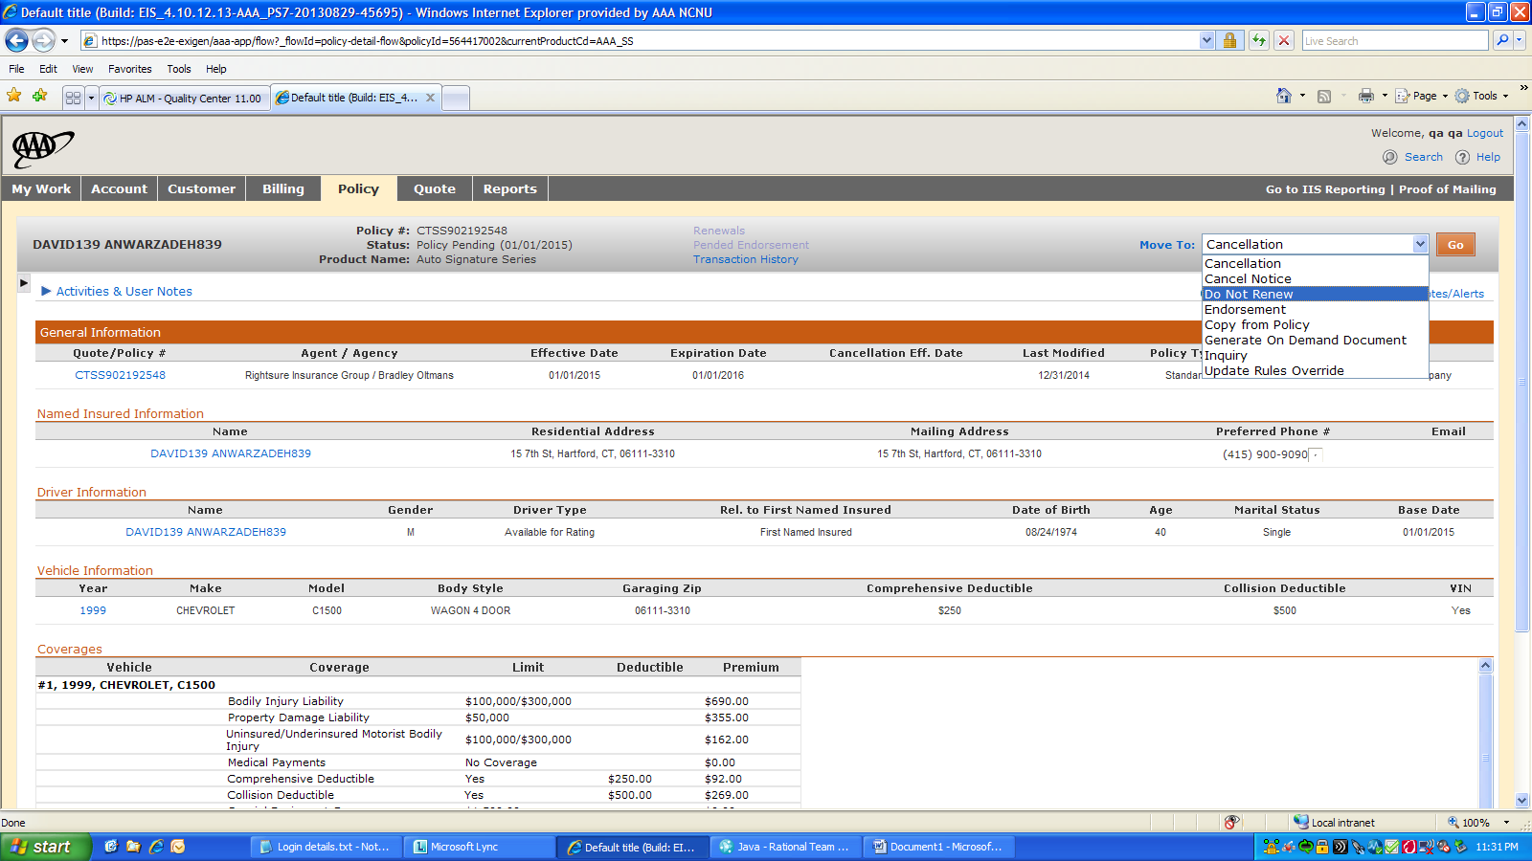

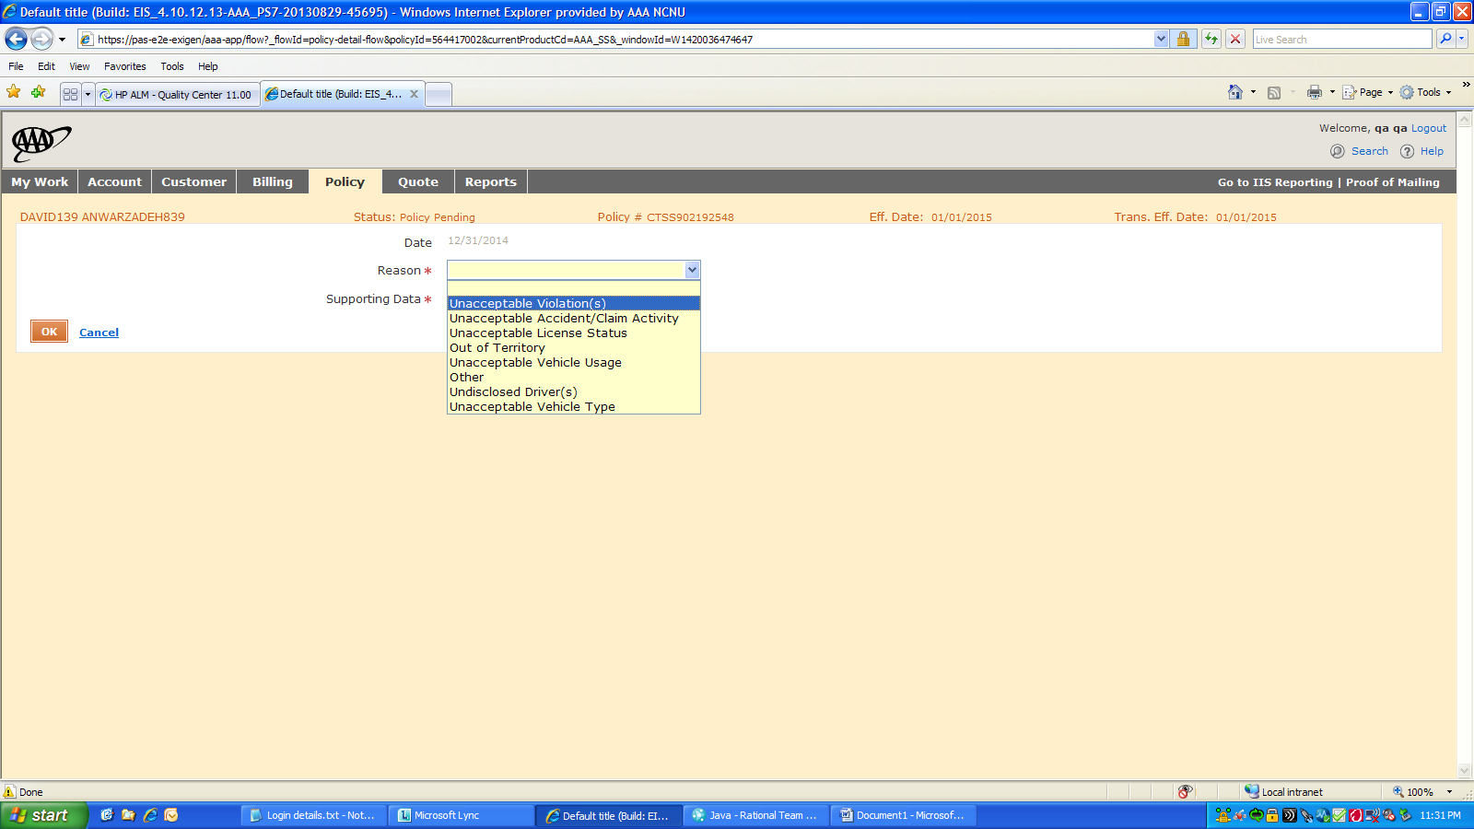

* When the common form template is not used, the story ID changes to 880-782.
* The reasons for Nonrenewal can be found in the Product Lookup for the state.
* The reasons should be added in Data Elements

## AA65DE Nonrenewal Notice

### System/UI Impact

| Page | Yes/No | Page Section |
| --- | --- | --- |
| Forms | | No | N/A | |
| *Note: Indicate section where form will display, if applies. See Policy, Driver, and Vehicle Endorsement tabs in the Product Lookup)* | |
| Documents | | No | N/A | |
| *Note: Indicate section/s where the form will display, defaults for “yes” and “no” button, if applies* | |
| GODD | | No | N/A | |
| *Note: Indicate whether document will appear on the page from Quote and/or Policy consolidated view, also the order of where on the page if new document* | |
| Related UW Rule/Task | | No | N/A | |
| *Note: This is a general reference to the related rule, if applicable. The rule requirements will be addressed in the UW assessment* | |

### Impacted Stories

| Type | Story # *(enter story # or N/A if form doesn’t require update to state specific story. Any legacy EKM story #s within the listed combo templates should be included in the story writing analysis)* |
| --- | --- |
| Form Content & Triggers | 880-782DE Form Content and Triggers - PAS Form AA65DE |
| Documents Page | N/A |
| GODD Page | N/A |
| Forms Page | N/A |
| RFI | N/A |
| Packet/Print story | N/A |

### Signature Rules(if any)

N/A

### Document Content and Applicable Triggers

* 880-782CL Form Content and Triggers - PAS Form # AA65DE is a light story. We need to write new VCs leveraging 880-713CL story.
* 880-713DE story exists where all VCs have been struck out after CR0408 changes.
  + 1. **Key pointers to keep in mind**
* In AA65DE, state specific language is printed on front and back pages of the notice.
* The back page includes Offer to Exclude Driver which will appear only when nonrenewal is due to Driver’s activity and there are more than 1 drivers on the policy.
* Offer to Exclude Driver will not display on the UI or print on the notice when there is only 1 driver on the policy.

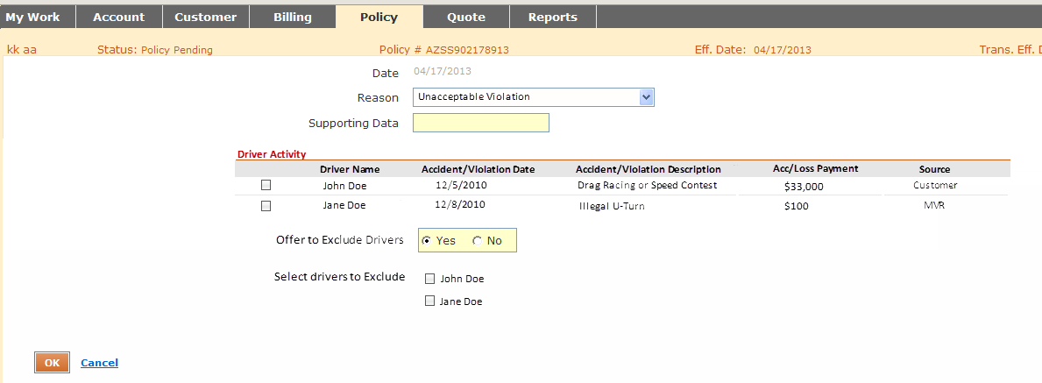

## AH65XX for KY, ID, NY : Nonrenewal Notice

### System/UI Impact

| Page | Yes/No | Page Section |
| --- | --- | --- |
| Forms | | No | N/A | |
| *Note: Indicate section where form will display, if applies. See Policy, Driver, and Vehicle Endorsement tabs in the Product Lookup)* | |
| Documents | | No | N/A | |
| *Note: Indicate section/s where the form will display, defaults for “yes” and “no” button, if applies* | |
| GODD | | No | N/A | |
| *Note: Indicate whether document will appear on the page from Quote and/or Policy consolidated view, also the order of where on the page if new document* | |
| Related UW Rule/Task | | No | N/A | |
| *Note: This is a general reference to the related rule, if applicable. The rule requirements will be addressed in the UW assessment* | |

### Impacted Stories

| Type | Story # *(enter story # or N/A if form doesn’t require update to state specific story. Any legacy EKM story #s within the listed combo templates should be included in the story writing analysis)* |
| --- | --- |
| Form Content & Triggers | 880-713KY Consolidated Form Content and Triggers -Nonrenewal Notice (AH65XX) |
| Documents Page | N/A |
| GODD Page | N/A |
| Forms Page | N/A |
| RFI | N/A |
| Packet/Print story | N/A |

### Signature Rules

N/A

### Document Content and Applicable Triggers

880-713KY story covers the content and triggers for this form.

The delta here was that state specific notice is added for KY.

Further, there was a delta wrt to number of days prior to Renewal Effective date, this notice is generated.

|  |  |  |
| --- | --- | --- |
| **State/Product** | **Notice Generates\*** | **Regulatory Rule** |
| **Standard**  *All state/products follow the standard unless listed differently below.* | R-35 |  |
| KY Auto & Property | -77 | 75 days + 2 mailing [AS400 is 72] |

This was communicated to the Functional team which covered it in 130-161KY story.

* + 1. **Key pointers to keep in mind**
* Stories for NY and ID were written in a similar manner as explained above.
* The reasons for Nonrenewal should be added in Data Elements from the Product Lookup for the state.

## AA65MD : Nonrenewal Notice

### System/UI Impact

| Page | Yes/No | Page Section |
| --- | --- | --- |
| Forms | | No | N/A | |
| *Note: Indicate section where form will display, if applies. See Policy, Driver, and Vehicle Endorsement tabs in the Product Lookup)* | |
| Documents | | No | N/A | |
| *Note: Indicate section/s where the form will display, defaults for “yes” and “no” button, if applies* | |
| GODD | | No | N/A | |
| *Note: Indicate whether document will appear on the page from Quote and/or Policy consolidated view, also the order of where on the page if new document* | |
| Related UW Rule/Task | | No | N/A | |
| *Note: This is a general reference to the related rule, if applicable. The rule requirements will be addressed in the UW assessment* | |

### Impacted Stories

| Type | Story # *(enter story # or N/A if form doesn’t require update to state specific story. Any legacy EKM story #s within the listed combo templates should be included in the story writing analysis)* |
| --- | --- |
| Form Content & Triggers | 880-782MD Form Content and Triggers - PAS Form # AA65MD |
| Documents Page | N/A |
| GODD Page | N/A |
| Forms Page | N/A |
| RFI | N/A |
| Packet/Print story | N/A |

### Signature Rules

N/A

### Document Content and Applicable Triggers

880-782MD story covers the content and triggers for this form.

880-713MD was initially written to capture the delta from CL version of the form. However, due to CR 408, the VCss were struck out and 880-713MD was made a light story.

AA65MD has state specific text on front and back pages and an offer to exclude drivers displayed on the notice.

The state specific text has static, dynamic and variable text. It also includes a signature line which is static.

Further, there was a delta wrt to number of days prior to Renewal Effective date, this notice is generated.

|  |  |  |
| --- | --- | --- |
| **State/Product** | **Notice Generates\*** | **Regulatory Rule** |
| **Standard**  *All state/products follow the standard unless listed differently below.* | R-35 |  |
| **MD** Auto & Property | -47 | 45 days notice + 2 days mailing |

This was communicated to the Functional team which covered it in 130-161MD story.

* + 1. **Key pointers to keep in mind**

N/A

## AA65PA : Nonrenewal Notice

### System/UI Impact

| Page | Yes/No | Page Section |
| --- | --- | --- |
| Forms | | No | N/A | |
| *Note: Indicate section where form will display, if applies. See Policy, Driver, and Vehicle Endorsement tabs in the Product Lookup)* | |
| Documents | | No | N/A | |
| *Note: Indicate section/s where the form will display, defaults for “yes” and “no” button, if applies* | |
| GODD | | No | N/A | |
| *Note: Indicate whether document will appear on the page from Quote and/or Policy consolidated view, also the order of where on the page if new document* | |
| Related UW Rule/Task | | No | N/A | |
| *Note: This is a general reference to the related rule, if applicable. The rule requirements will be addressed in the UW assessment* | |

### Impacted Stories

| Type | Story # *(enter story # or N/A if form doesn’t require update to state specific story. Any legacy EKM story #s within the listed combo templates should be included in the story writing analysis)* |
| --- | --- |
| Form Content & Triggers | 880-782PA Form Content and Triggers - PAS Form AA65PA |
| Documents Page | N/A |
| GODD Page | N/A |
| Forms Page | N/A |
| RFI | N/A |
| Packet/Print story | N/A |

### Signature Rules

N/A

### Document Content and Applicable Triggers

880-782PA story covers the content and triggers for this form.

880-713MD was initially written to capture the delta from CL version of the form. However, due to CR 408, the VCs were struck out and 880-713PA was made a light story.

AA65PA has state specific text on front and back pages and includes a signature line. However, signature validation is not required.

Further, there was a delta wrt to number of days prior to Renewal Effective date, this notice is generated.

|  |  |  |
| --- | --- | --- |
| **State/Product** | **Notice Generates\*** | **Regulatory Rule** |
| **Standard**  *All state/products follow the standard unless listed differently below.* | R-35 |  |
| **PA** Auto & Property | -60 | 60 days = 2 days mailing ?? |

This was communicated to the Functional team which covered it in 130-161PA story.

* + 1. **Key pointers to keep in mind**

N/A

6. Reference Documents

| Document Name | Document Description |
| --- | --- |
| [880-713CL](https://ekm1.stage.exigengroup.com/EKMWiki/index.php/880-713CL_Form_Contents_and_Triggers_-_PAS_form_AH65XX) | Link for 880-713CL and AH65XX document |
| [130-161CL](https://ekm1.stage.exigengroup.com/EKMWiki/index.php/130-161CL_Ability_to_determine_number_of_days_notice_required_for_legal_notice_of_non-renewal) | Link to 130-161CL Assessment |
| [CR383](https://ekm1.stage.exigengroup.com/EKMWiki/index.php/CR383_Non_Renewal_and_Cancellation_Notice) | Link for CR383 Assessment document |
| [CR0408](https://ekm1.stage.exigengroup.com/EKMWiki/index.php/CR0408_-_Common_Forms_AH61XX_and_AH65XX) | Link for CR0408 Assessment document |
| [880-713DE](https://ekm1.stage.exigengroup.com/EKMWiki/index.php/880-713DE_-_Form_Contents_and_Triggers_-_PAS_Form_AH65XX) | Link for 880-713DE document |
| [880-782DE](https://ekm1.stage.exigengroup.com/EKMWiki/index.php/880-782DE_Form_Content_and_Triggers_-_PAS_Form_AA65DE) | Link for 880-782DE and AH65XX document |
| [880-713ID](https://ekm1.stage.exigengroup.com/EKMWiki/index.php/880-713ID_-_Form_Contents_and_Triggers_-_Nonrenewal_Notice) | Link for 880-713ID and AH65XX document |
| [880-713KY](https://ekm1.stage.exigengroup.com/EKMWiki/index.php/880-713KY_-_Form_Contents_and_Triggers_-_Nonrenewal_Notice) | Link for 880-713KY and AH65XX document |
| [130-161KY](https://ekm1.stage.exigengroup.com/EKMWiki/index.php/130-161KY_Ability_to_determine_number_of_days_notice_required_for_legal_notice_of_non-renewal) | Link to 130-161KY Assessment |
| [880-713NY](https://ekm1.stage.exigengroup.com/EKMWiki/index.php/880-713NY_-_Form_Contents_and_Triggers_-_PAS_Form_AH65XX) | Link for 880-713NY and AH65XX document |
| [130-161NY](https://ekm1.stage.exigengroup.com/EKMWiki/index.php/130-161NY_Ability_to_determine_Number_of_Days_Notice_required_for_Legal_Notice_of_Non-Renewal) | Link to 130-161NY Assessment |
| [880-713MD](https://ekm1.stage.exigengroup.com/EKMWiki/index.php/880-713MD_-_Form_Contents_and_Triggers_-_PAS_Form_AH65XX) | Link for 880-713MD document |
| [880-782MD](https://ekm1.stage.exigengroup.com/EKMWiki/index.php/880-782MD_Form_Content_and_Triggers_-_PAS_Form_AA65MD) | Link for 880-782MD and AH65XX document |
| [130-161MD](https://ekm1.stage.exigengroup.com/EKMWiki/index.php/130-161MD_Ability_to_determine_number_of_days_notice_required_for_legal_notice_of_non-renewal) | Link for 130-161MD Assessment document |
| [880-713PA](https://ekm1.stage.exigengroup.com/EKMWiki/index.php/880-713PA_-_Form_Contents_and_Triggers_-_PAS_Form_AH65XX) | Link for 880-713PA document |
| [880-782PA](https://ekm1.stage.exigengroup.com/EKMWiki/index.php/880-782PA_-_Form_Content_and_Triggers_-_PAS_Form_AA65PA) | Link for 880-782PA and AH65XX document |
| [130-161PA](https://ekm1.stage.exigengroup.com/EKMWiki/index.php/130-161PA_Ability_to_determine_Number_of_Days_Notice_required_for_Legal_Notice_of_Non-Renewal) | Link to 130-161NY Assessment |

About Deloitte

Deloitte provides audit, tax, consulting, and financial advisory services to public and private clients spanning multiple industries. With a globally connected network of member firms in 140 countries, Deloitte brings world-class capabilities and deep local expertise to help clients succeed wherever they operate. Deloitte's 165,000 professionals are committed to becoming the standard of excellence.

Deloitte's professionals are unified by a collaborative culture that fosters integrity, outstanding value to markets and clients, commitment to each other, and strength from cultural diversity. They enjoy an environment of continuous learning, challenging experiences, and enriching career opportunities. Deloitte's professionals are dedicated to strengthening corporate responsibility, building public trust, and making a positive impact in their communities.

Deloitte refers to one or more of Deloitte Touche Tohmatsu, a Swiss Verein, and its network of member firms, each of which is a legally separate and independent entity. Please see www.deloitte.com/about for a detailed description of the legal structure of Deloitte Touche Tohmatsu and its member firms. Please see <http://www.deloitte.com/us/about> for a detailed description of the legal structure of Deloitte LLP and its subsidiaries.

Internal Usage Statement

This publication is for internal distribution and use only among personnel of Deloitte Touche Tohmatsu, its member firms, and its and their affiliates. Deloitte Touche Tohmatsu, its member firms, and its and their affiliates shall not be responsible for any loss whatsoever sustained by any person who relies on this publication.

Copyright © 2013 Deloitte Development LLC. All rights reserved.

Member of Deloitte Touche Tohmatsu